Forces and Friction - Questions
May 2014 Mathematics Advanced Paper 1: Mechanics 1

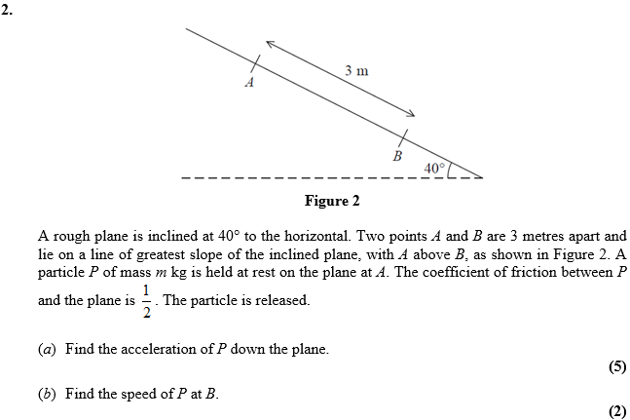

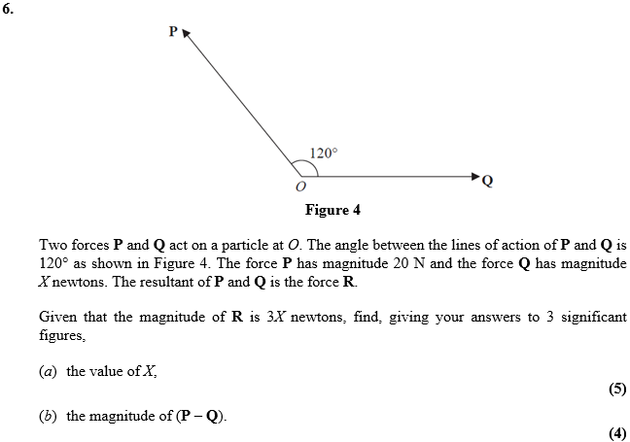

May 2012 Mathematics Advanced Paper 1: Mechanics 1

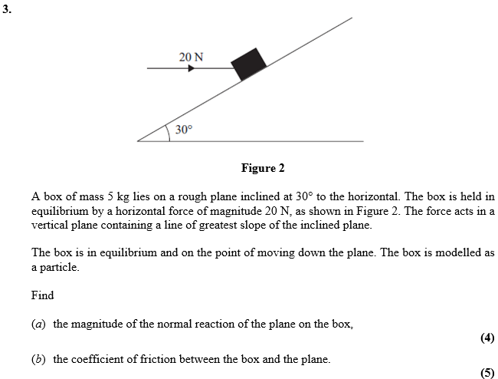

Jan 2012 Mathematics Advanced Paper 1: Mechanics 1

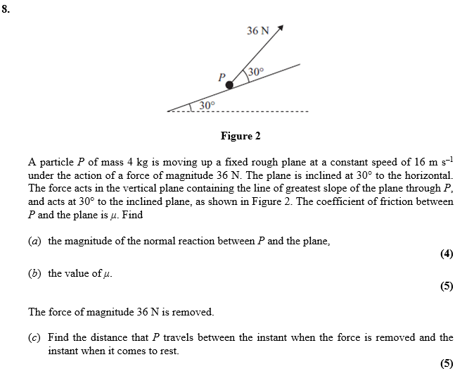

May 2011 Mathematics Advanced Paper 1: Mechanics 1

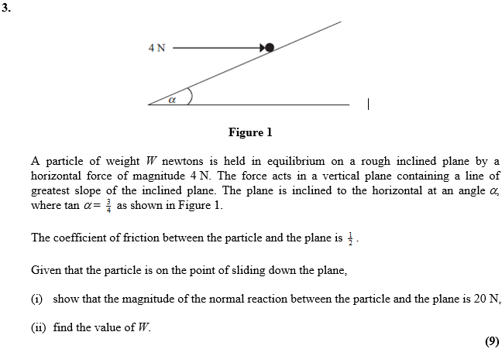
Jan 2011 Mathematics Advanced Paper 1: Mechanics 1

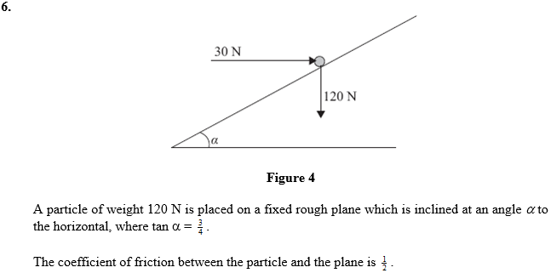
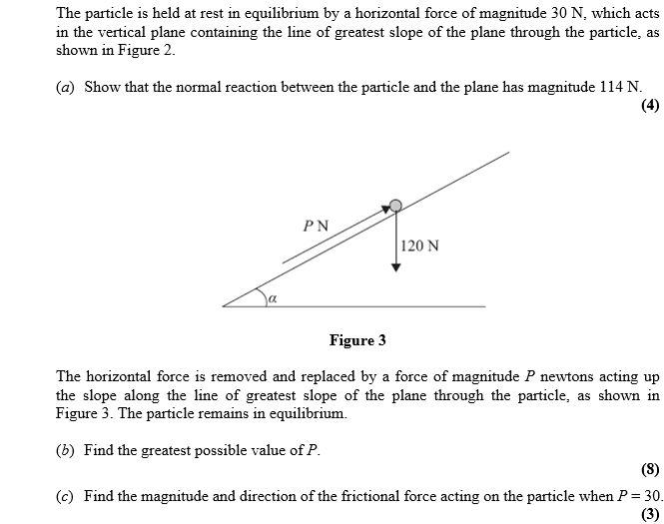

May 2010 Mathematics Advanced Paper 1: Mechanics 1

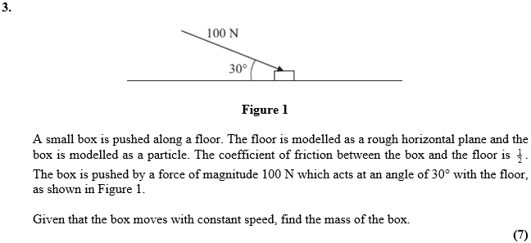

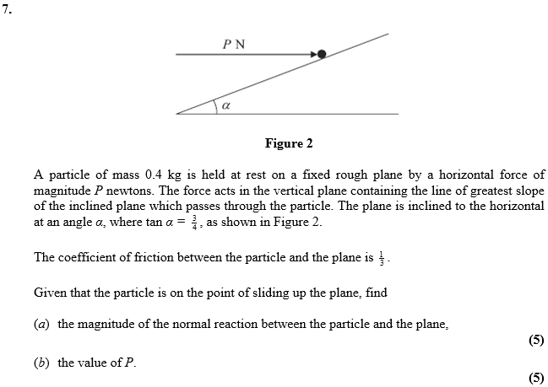

Jan 2010 Mathematics Advanced Paper 1: Mechanics 1

